Verification Guide

1. For any new brand validation :

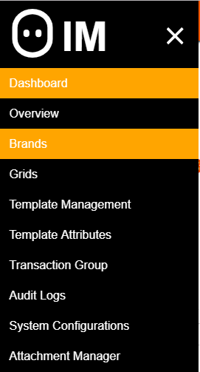

Select Brands from main menu.

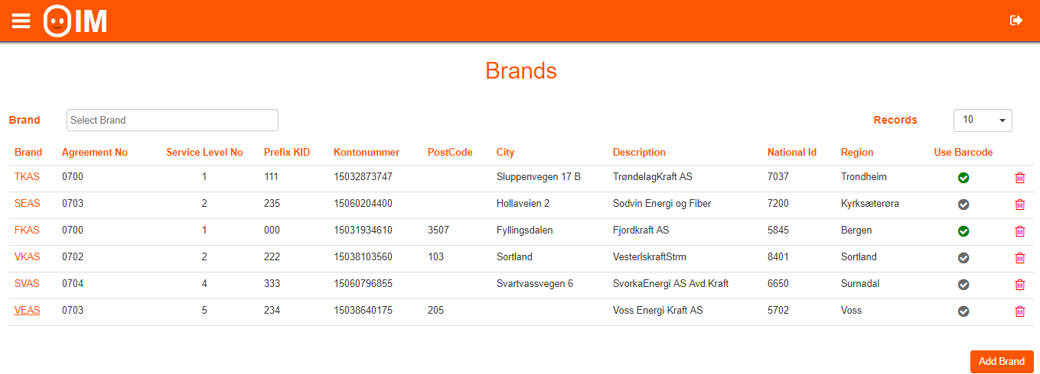

* Verify the Kontonummer
* Description
* Use Barcode or not
* Address configured

1. New Grid Validation:

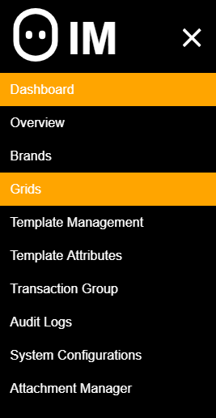

Select Grids from main menu.

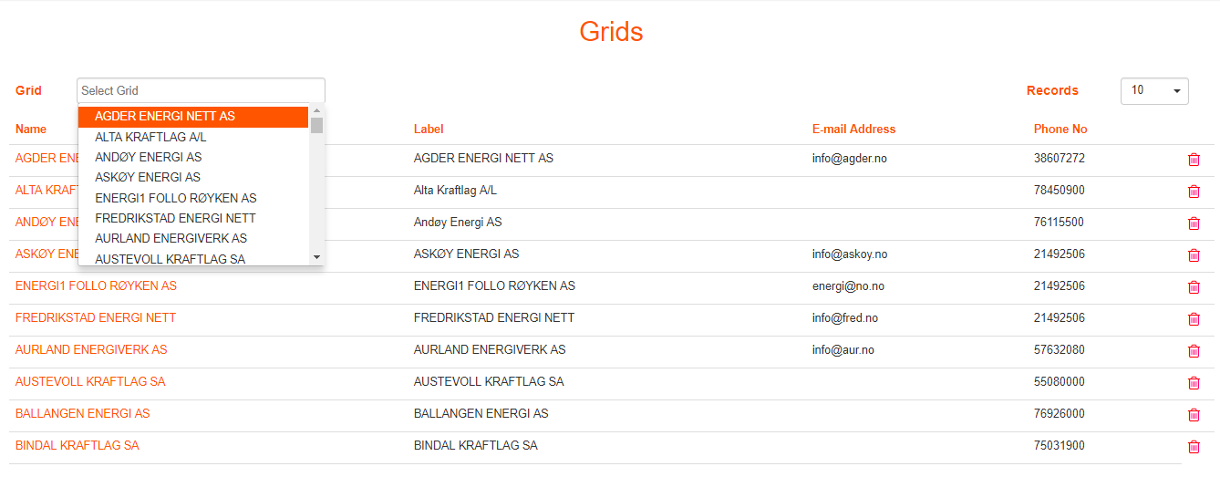

Select Grid newly configured/changed.

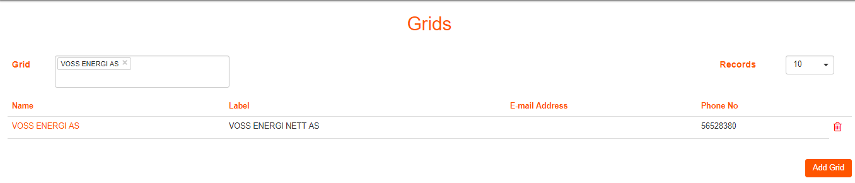

* Verify Label
* Phone number.

1. New Transaction Category /group validation:

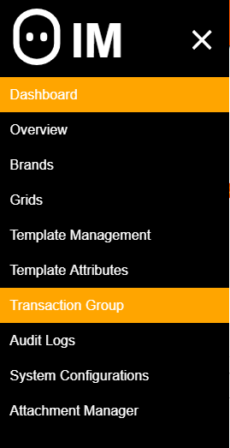

Select Transaction Group from main menu.

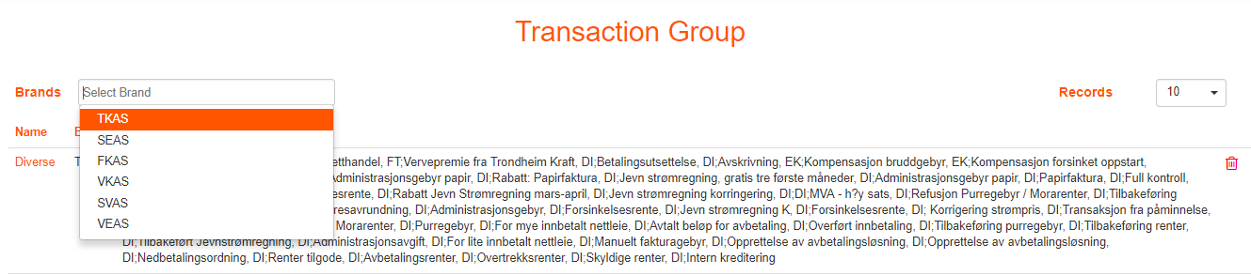

Select Brand to verify Transaction group participants.

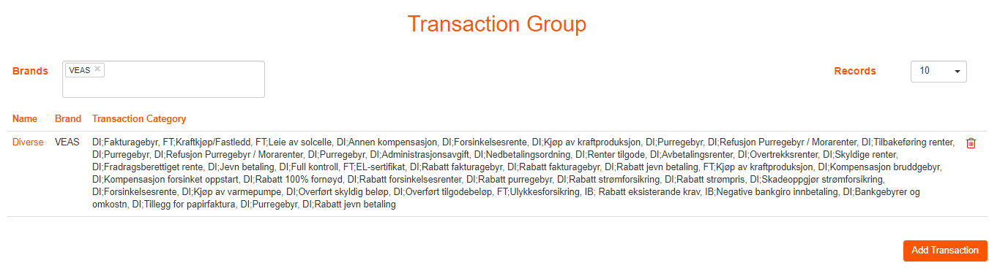

* Verify the Group for a brand and group participants.

1. Attachment Configuration Validation :

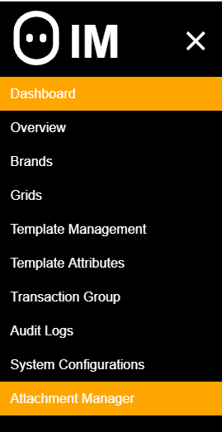

Select Attachment Manager from the main menu.

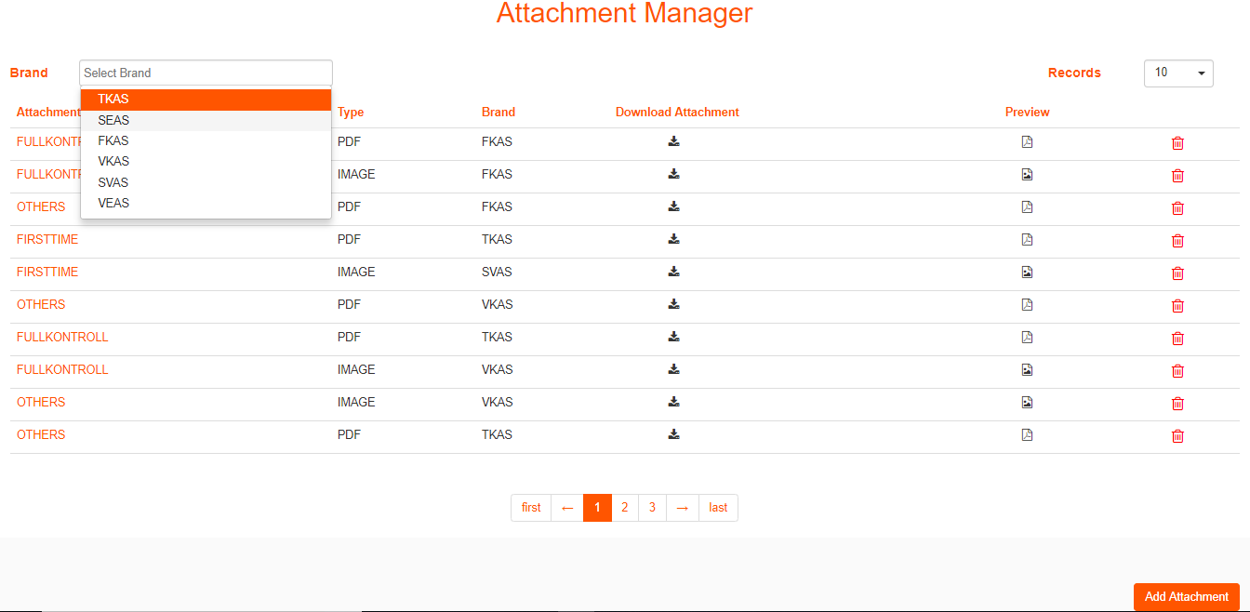

Select Brand to verify Advertisement PDF/Campaign image

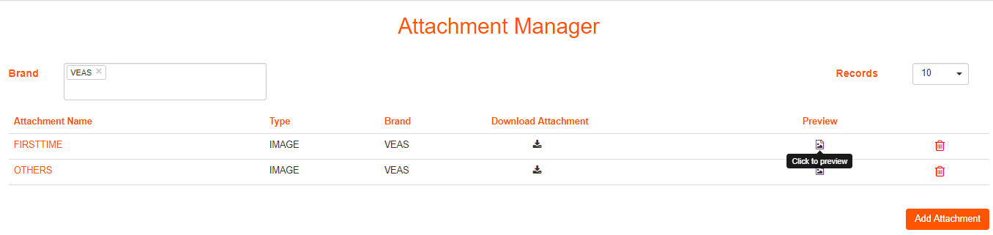

Select click on Preview button for a specific attachment Type to verify the Attachment.

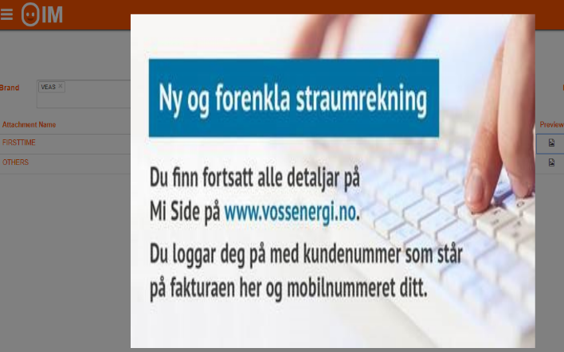

* Verify the Campaign image.

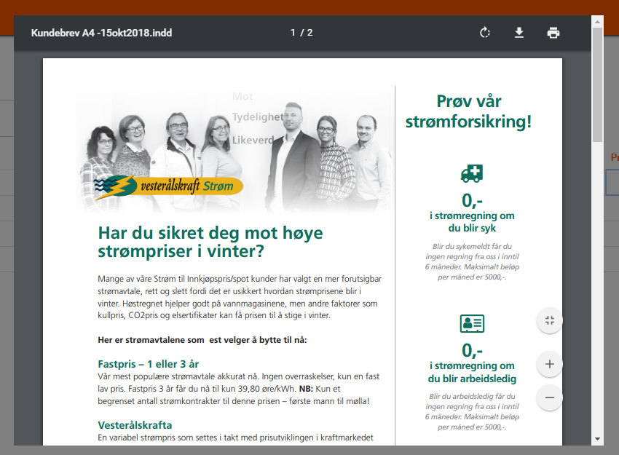

* Preview of Advertisement PDF.

1. Template validation :

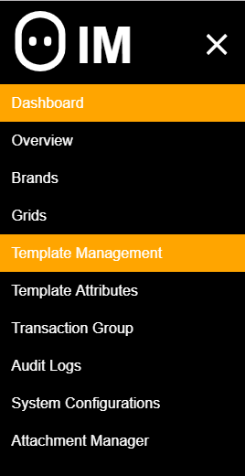

Click on Template Management from main menu.

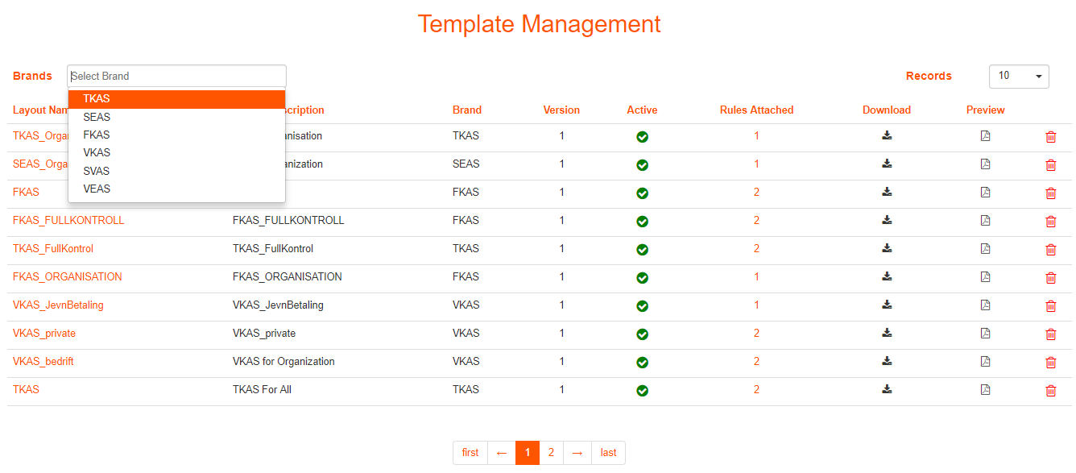

Select Brand to Verify.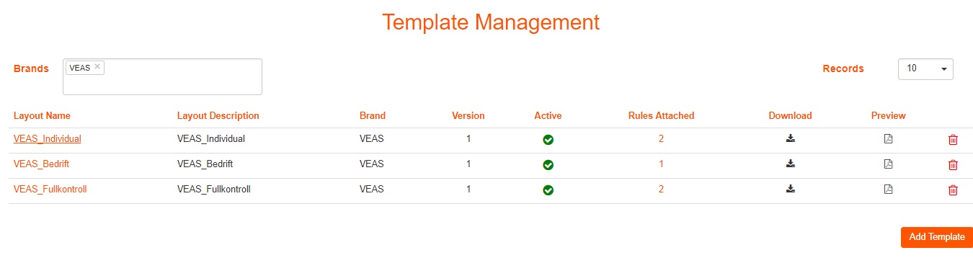

* Verify Layout Name and Brand
* Verify the Layout is active.

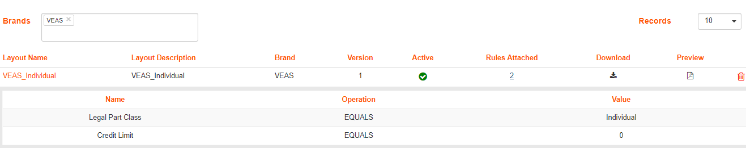

* Verify Rules configured for the selected layout.

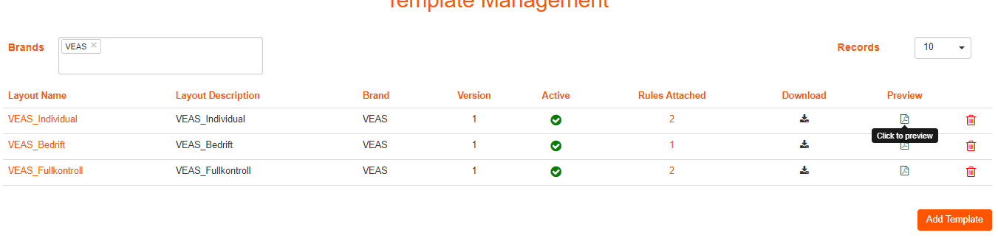

* Verify that the layout is uploaded properly
* Verify that there are no special characters for the layout.
* Verify that the layout design is as per layout rules configured.

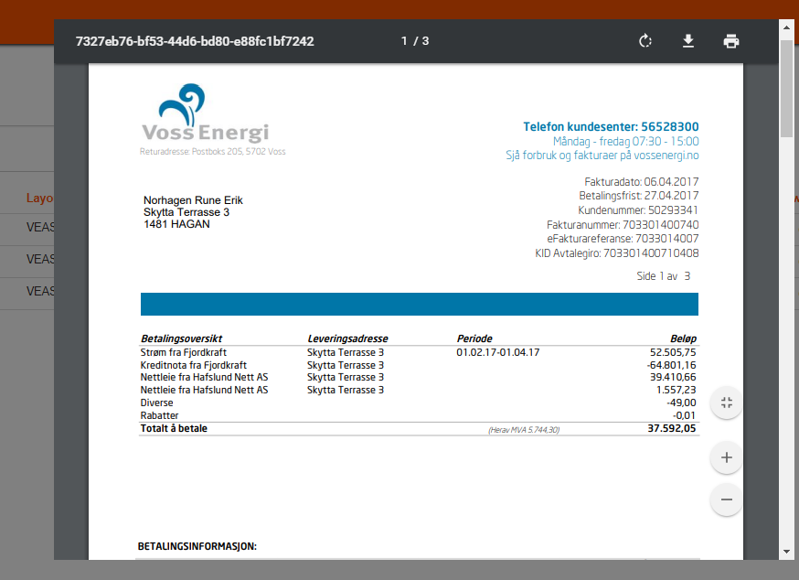

The preview will show the sample PDF before invoice is generated.

* Verify Logo for a specific brand for a specific layout.
* Verify color (RGB) for a layout.
* Verify Campaign image/ Chart will be visible for a layout or not.

Currently we have a sample statement file which has hardcoded information (not brand specific configuration). In future we will support the preview with brand specific configuration so that we can have a preview of invoice generated for a specific brand.